# SOFTWARE REQUIREMENT SPECIFICATIONS

**Shortcut keys App**

**Submitted by**:

**Sonam Choki (12190080)**

1. **Introduction**

The following section provides an overview of derived software requirements specification for the Shortcut keys application. To begin with, purpose of the document is presented and scope of the project is specified with the particular focus on what the resultant software will do. The document will also include functional requirement and non-functional requirements.

The set of shortcut keys is the subject of my project. Shortcut keys Application allows users to quickly access shortcut keys from an application's list of keys, as well as add shortcut keys who are not already present. The main aim of this paper is to build a shortcut keys application that makes learning shortcut keys simple and provides a learning structure for users to study shortcut keys.

* 1. Purpose

The purpose of this document is to provide a detailed description of the Shortcut keys Application's requirements. It will show the purpose and complete declaration for the system's development, as well as the system software specifications.

* 1. Scope

The Shortcut Keys is an Android mobile application that allows users to quickly access shortcut keys and save time without having to go online. Furthermore, users can use the keyword search to find their desired phrase, and the application will show it to them.

1. **Requirements**
   1. Functional Requirements

This section describes the high level of functionality of Shortcut keys Application.

1. User Registration

When a user uses the app, they will need to register to the system.

User will need to provide information such as name, email address, and password.

1. Search

User can search for desired shortcut keys by giving hint of their word or giving keyword.

1. Add

User can add new shortcut keys which are not present in the application.

1. Report

User can report respective shortcut keys which do not word or which are repeated and also which are irrelevant added by users.

1. Exit

Registered user can exit the app when desired.

* 1. Non-functional requirements

1. Supportability

Shortcut keys application can be deployed in any android smartphone since majority of the population uses smartphones and android being the cheaper variant.

1. Availability

Shortcut keys is an application that will have as many shortcut keys as possible and make available to users.

1. Usability

The mobile application will have a user friendly interface and it will be achieved by the use of clear text and information.

* 1. Software Requirements

App Development Tools

* Java SE jdk1.8.0_111 and above
* Android SDK-25 and above
* Android Studio version 2.3.3 and above
* Andriod OS 2.3(“Gingerbread”) or higher.
* Firebase

Documentation and Design Tools

* Latex
* MS Word
* Adobe XD (UI Design)

1. **Hardware requirements**

* Processor: dual core 64-bit, 2GHz intel core i3
* RAM : 4GB
* Hard disk Space: 500Mb and 1GB for android SDK
* Windows 8 and above

1. **System Design**

1. 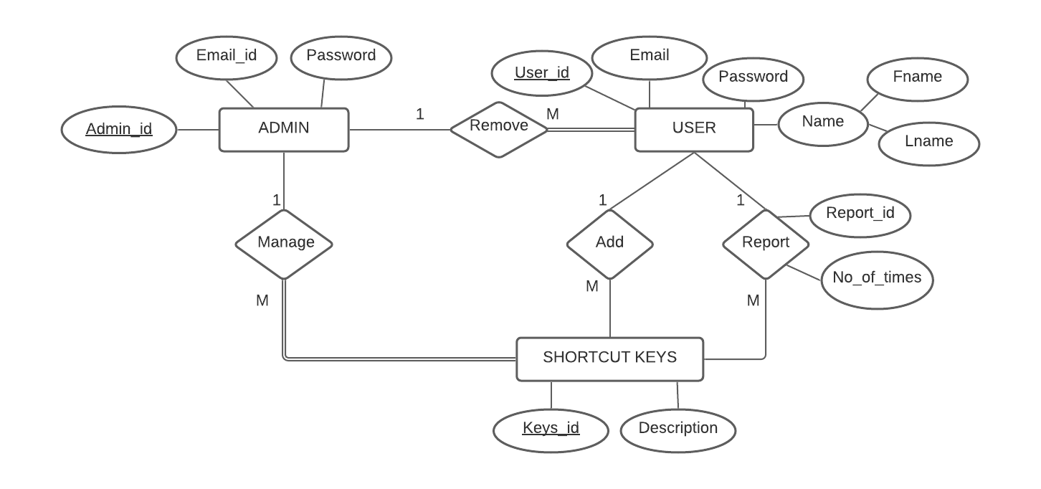Entity Relationship Diagram (ERD)
2. 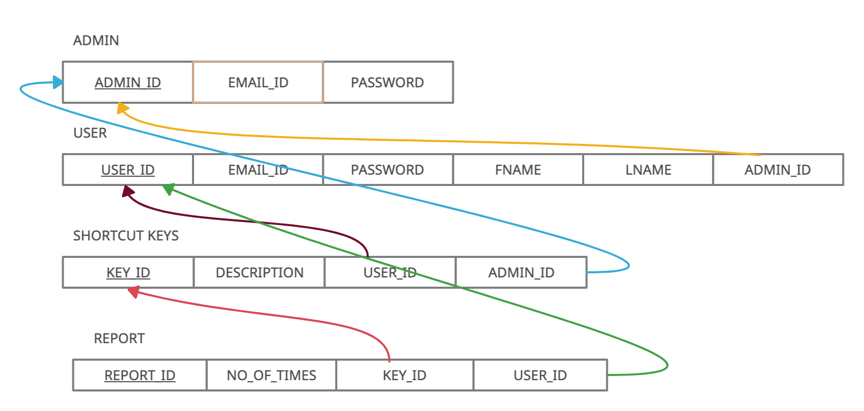Relation schema
3. Use Case
4. 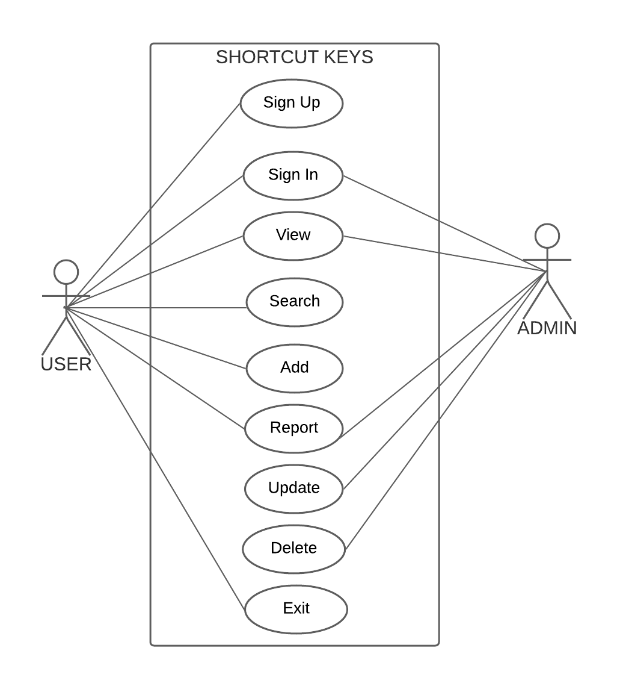
5. Sequence Diagram